Helen Wilkins – Pianist
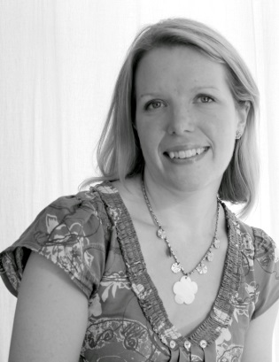
Bristol born pianist Helen Wilkins attended Katharine Lady Berkeley’s School in Wotton-under-Edge, Gloucestershire, receiving piano lessons from Christine Robertson until she went to University. Helen obtained a BA Hons degree in music at Exeter University, studying piano with Margaret Gulley and Kate Miller, and then trained as a secondary school teacher, specialising in music. After this, Helen taught music in Cirencester and Wells, becoming Head of Music at the Blue School in Wells from 2003-2013.
In 2013 she took the exciting step of leaving full time teaching to pursue freelance work as a pianist, accompanist and private music teacher. Helen has performed live in concerts across the south-west as a soloist and an accompanist, and has been the accompanist of the Cantabile Ladies Choir in Wells since 2013. She has an increasing number of private piano students in Bristol and Somerset, teaching both adults and children, and is passionate about sharing her love of music with others as ‘food for the soul’.

